This dataset was used as an assessment in the final stage of the application for the CooperVision Commercial Analyst Role. While it is a mock dataset, it has a sense of realistic scenarios. The presentation I created was stated to be the best out of all candidates, enabling me to get an offer for the role.

Figure 1

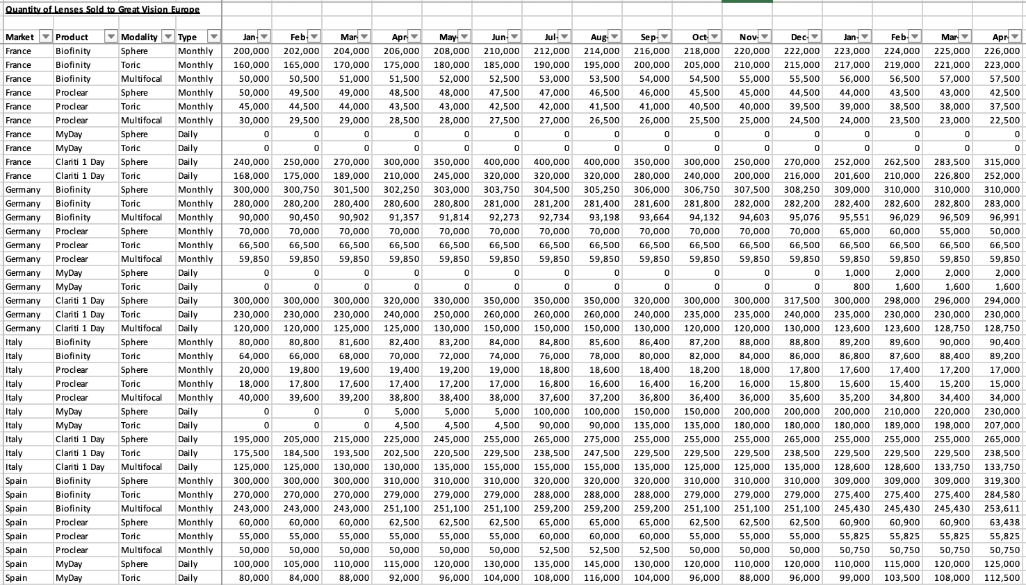

Figure 1 is the orginal set of data, which required immense data cleaning as it was not feasible to analyse it at this point. The market is split into “Monthly” and “Daily” Type of Lens. Therefore, I split the data into 2 excel workbooks to analyse their performances individually and aggregated the performances within quarters.

Monthly Lens Market

Figure 2
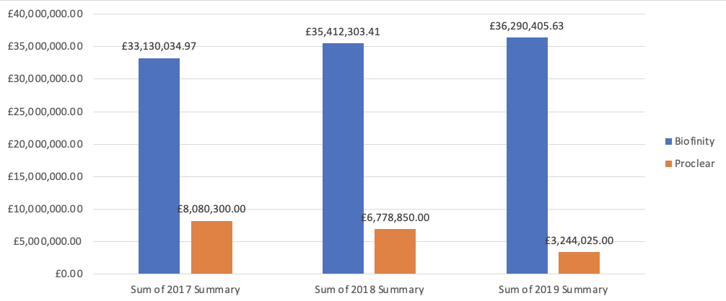

Figure 3

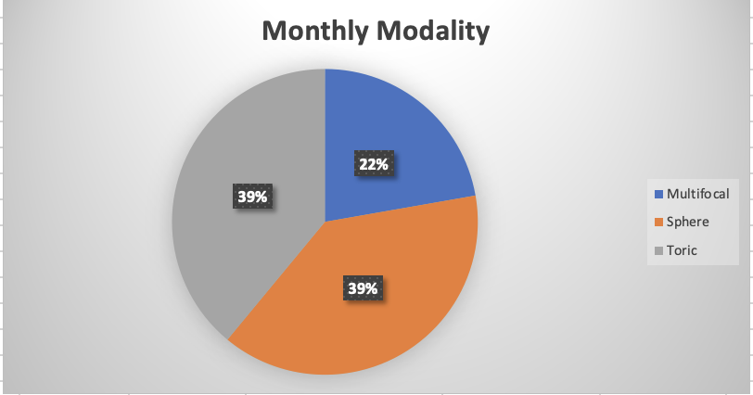

Biofinity Dominates all markets. In terms of Modality, Sphere and Toric are 40% which means Astigmatism, near-sightedness, farsightedness are the most common problems. Multifocal is the least common which means that Presbyopia is not common amongst these markets but does not mean we should stop the supply.

Figure 4

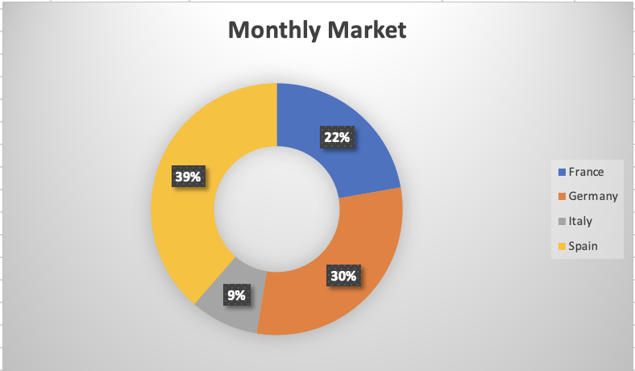

Italy

Figure 5

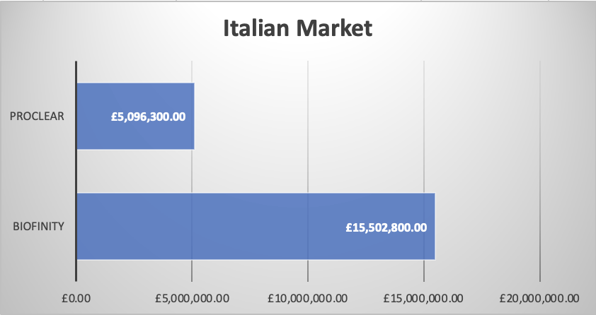

They hold the lowest contribution to our sales, only 9%.[See Figure 4]
This could be because there is a large supply of Proclear, and Italians actually prefer Biofinity, which is how we can improve that.
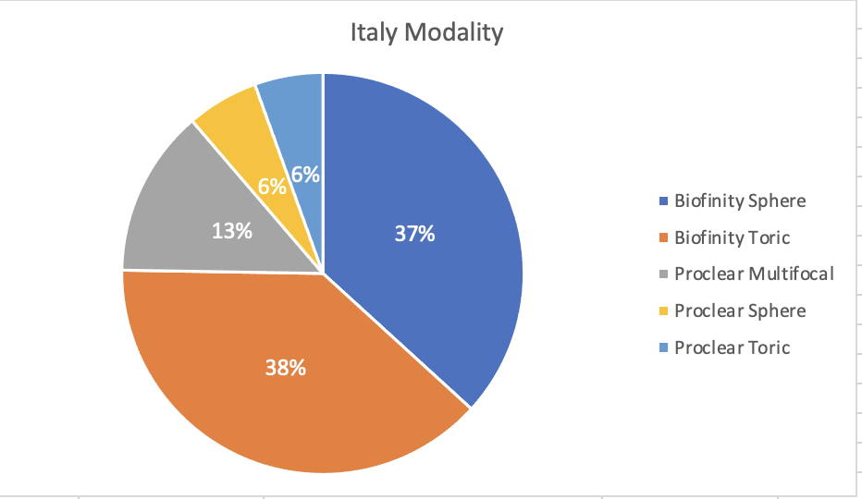

We can focus on distributing Biofinity Sphere, Toric, and Proclear Multifocal to maximize our current sales. In the future we should distribute Biofinity Multifocal

Spain

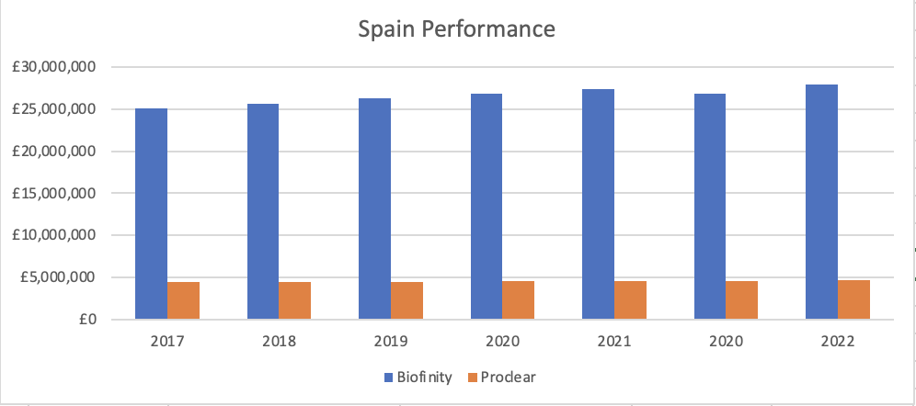

Spain is the highest with 39%[See Figure 4]. Biofinity still dominates and is considered our cash cow. To maximize sales in Spain, we should focus on using Biofinity. Without COVID-19, it could potentially reach a combined 32 million in sales in 2022.

Germany and France
To improve all markets, we should stop supplying Proclear in France, Germany,

Daily Lens Market
Multifocal is consistent with the 2 sheets as it helps people with presbyopia
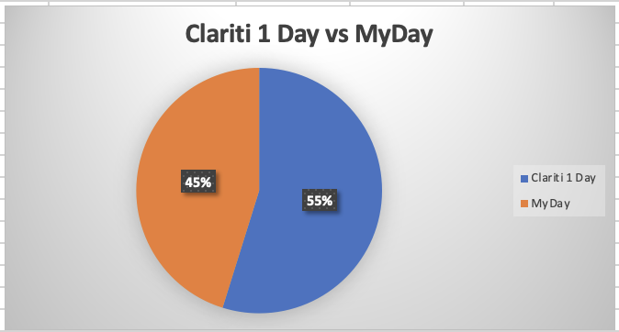

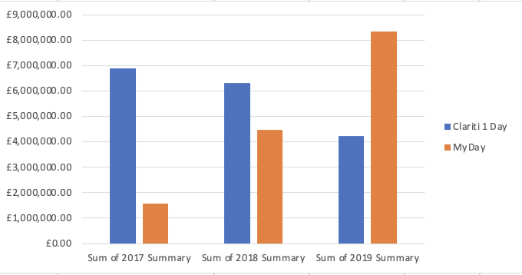

While it may look like that Clariti 1 Day is performing better, the trend of growth is decreasing substantially per year, while My Day has increased sales.

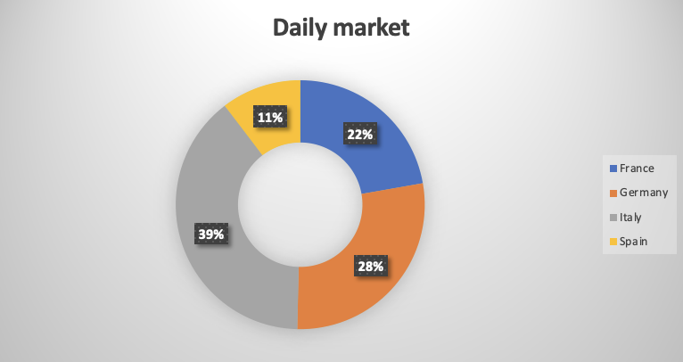

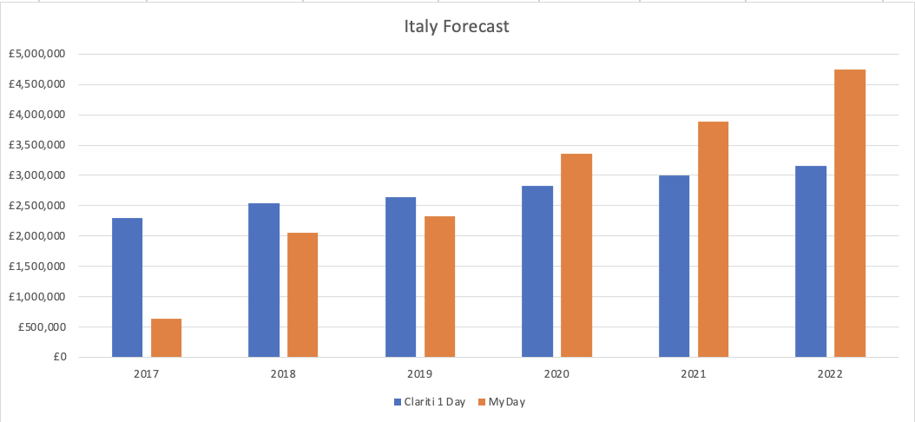

Italy
Italians dominate the market taking 39% of the market share. Based on the projection from 2020 and onwards, MyDay has the fastest growth rate per Year in Italy, in contrast to the rest of the world however Clariti 1 Day is still a cash cow. Improve Italy by increasing sales from the 1st and 4th Quarter through meeting demand. Italy performed the best because both products were supplied on time. Invest in both products as they have high growth rate.

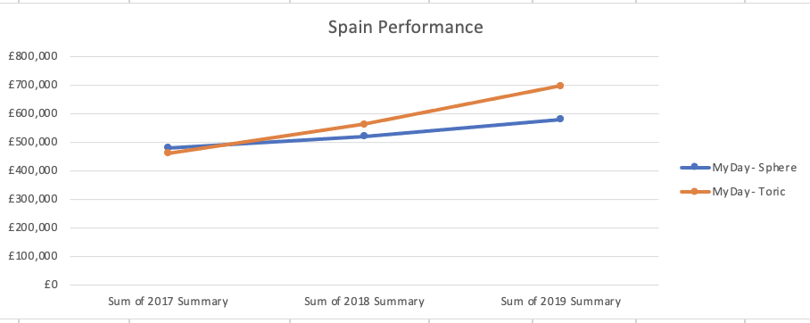

Spain
Spain has the lowest with 11%. The most popular product, MyDay is not performing well in Spain compared to many other places which could mean they just have a preference of Monthly contacts.

Another factor is Clariti 1 Day is not supplied in Spain which explains why they have the lowest amount of sales. Clariti 1 Day is getting extremely popular in a short amount of time and Spain is deprived from it and this is an issue as there could be people who are suffering from presbyopia. For now, we can keep supplying Spain with MyDay Toric while also releasing Clariti 1 Day. The Spaniards have a tendency to not buy that much in the 1st and 4th Quarter of every year. In order to improve the sales, we can decrease prices and increase the supply during those quarters.

Germany and France

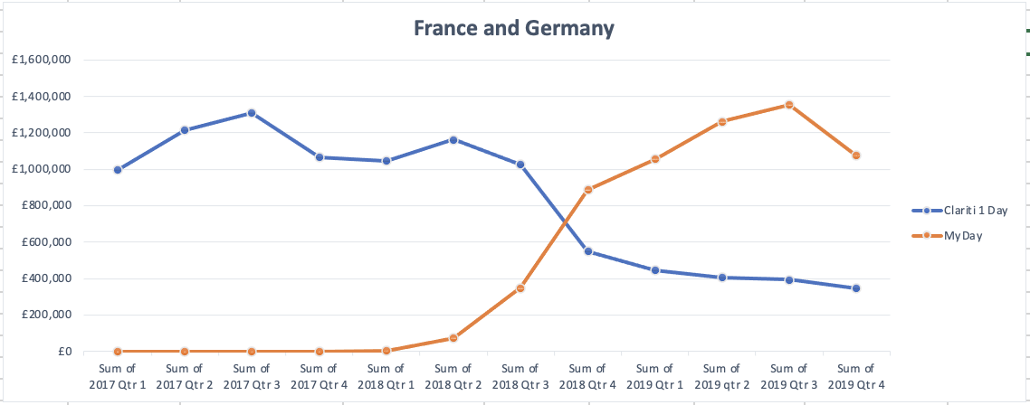

Germany and France
France and Germany produce high sales, but they did not receive MyDay in the first quarters. They also lose interest in Clariti 1 day every year therefore it a bad investment, so instead we should supply MyDay. In general, there is a tendency for most markets to buy less products in winter seasons.

In conclusion:

The Spanish market prefers Monthlies in contrast to Dailies. The Italians prefer Dailies in contrast to Monthlies therefore we should adjust our supply chain to meet their demands in order to increase our revenue.

Monthly contact lenses are eco-friendlier because you will be throwing out fewer lenses compared to dailies. You usually only use 12 pairs every year if you choose monthly contacts, resulting in less waste that ends up in landfills.

Germany and France stay consistent with their preferences throughout the analysis. Therefore, if we want to release a product, we should first understand what kind of people are we targeting and products should be released earlier if we want better results.

